Rajleen Kaur  
00713207218

CSE- 1

MACHINE LEARNING

LAB PROGRAM

Submission -3

Github link : [LAB Program - 3](https://github.com/kaurrajleen/Ml/tree/main/ML-Lab_Program-3)

**EXPERIMENT-3**

# AIM:

Estimate the accuracy of decision classifier on breast cancer dataset using 5 fold cross validation.

# ALGORITHM:

1. Select the best attribute using Attribute Selection Measures (ASM) to split the records.
2. Make that attribute a decision node and breaks the dataset into smaller subsets.
3. Starts tree building by repeating this process recursively for each child until one of the conditions will match:
   1. All the tuples belong to the same attribute value.
   2. There are no more remaining attributes.
   3. There are no more instances.

# PROGRAM CODE SNIPPET:

## LOADING DATA SET:

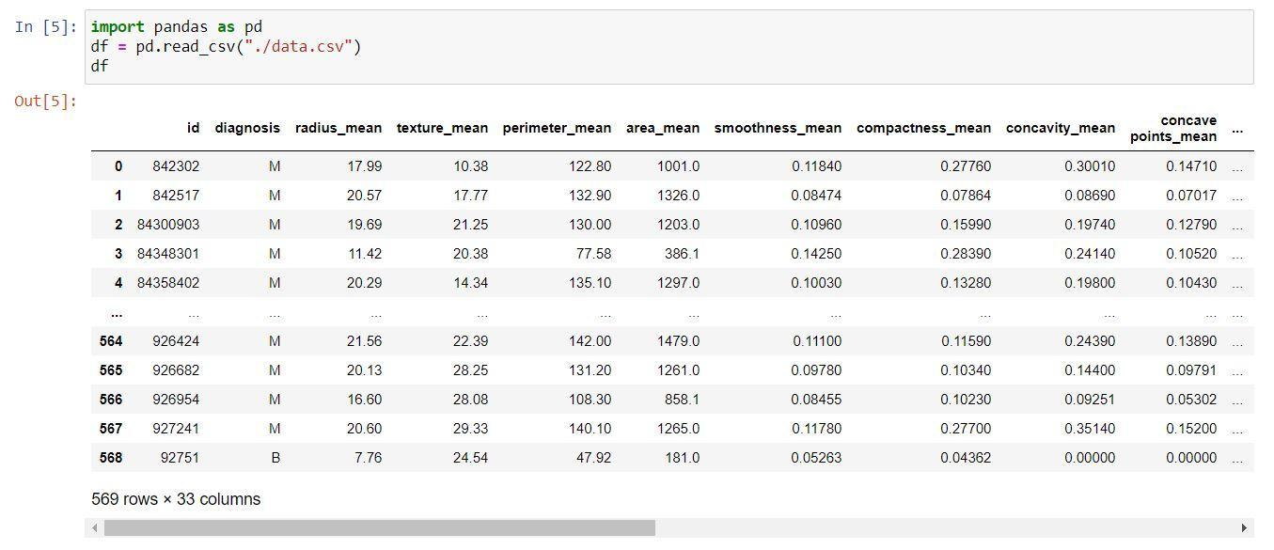

## PREPROCESSING:

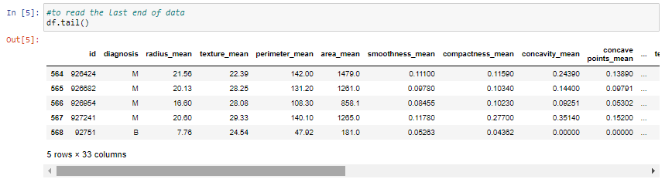

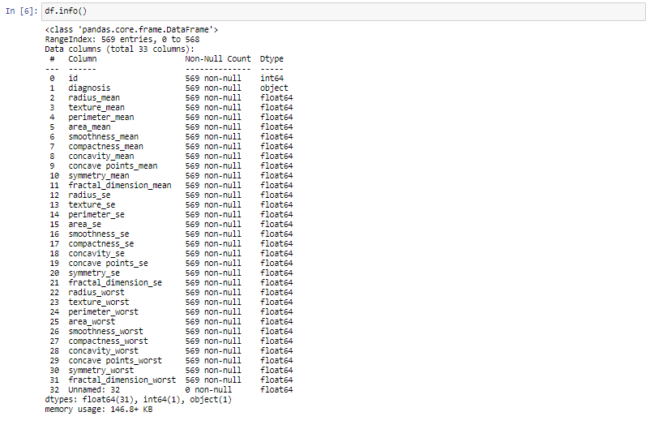

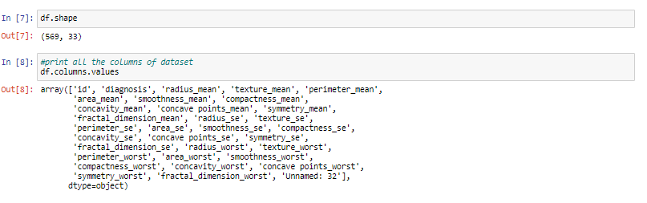

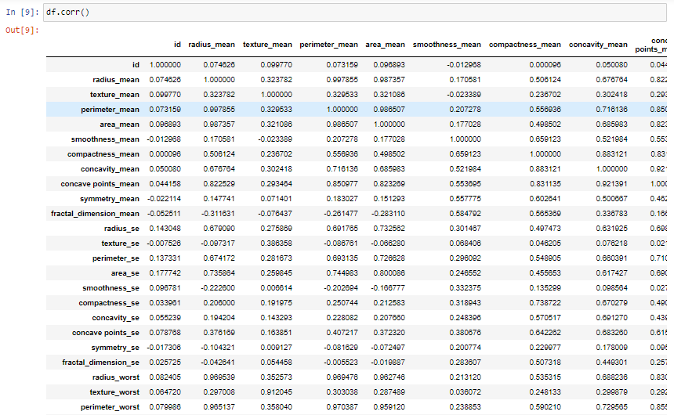

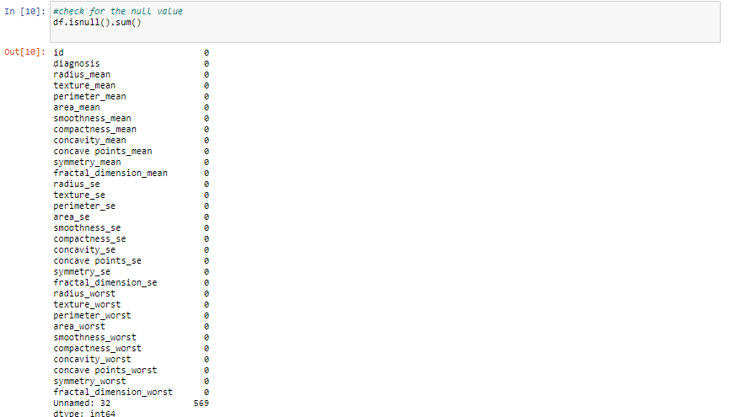

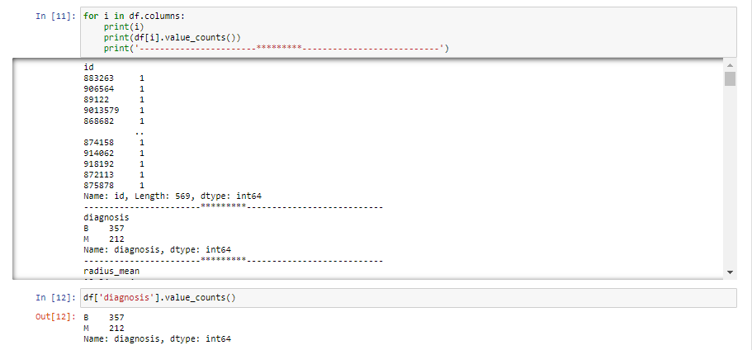

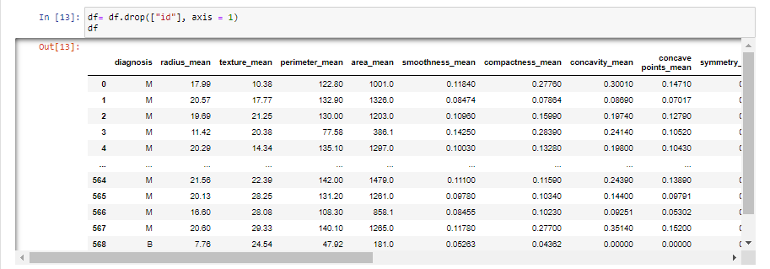

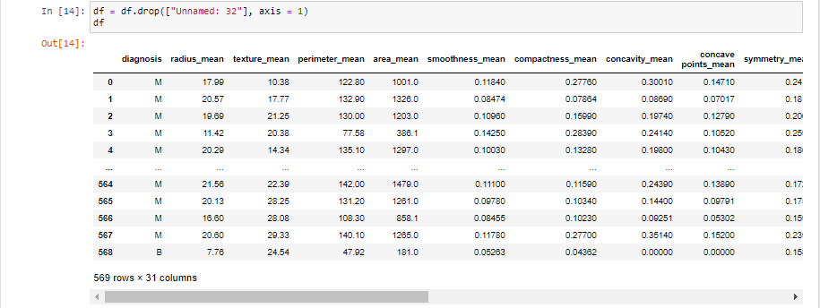

## VISUALIZATION:

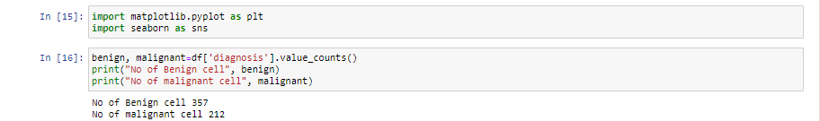

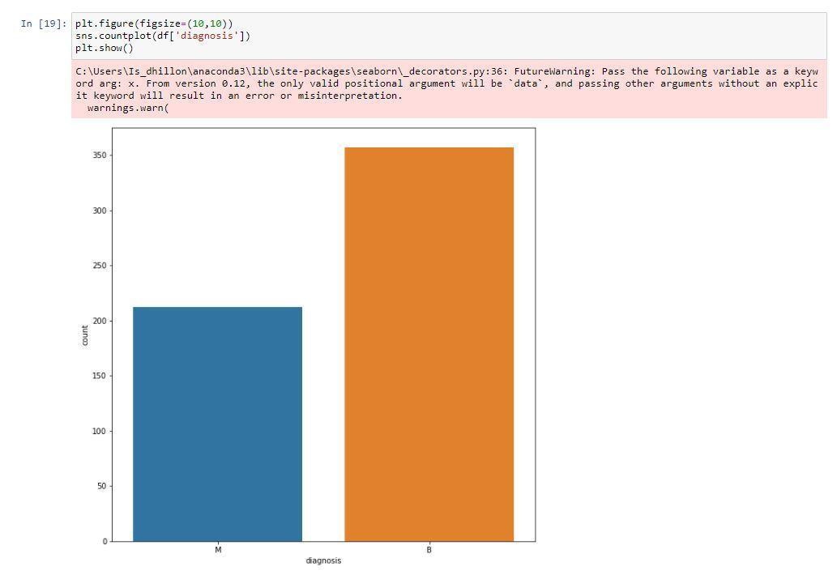

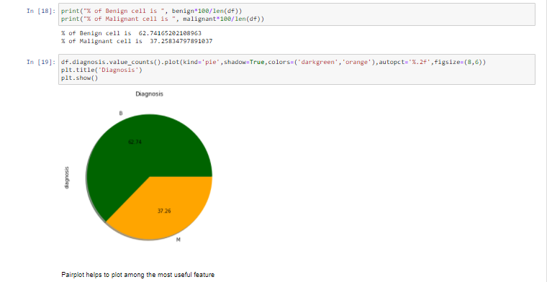

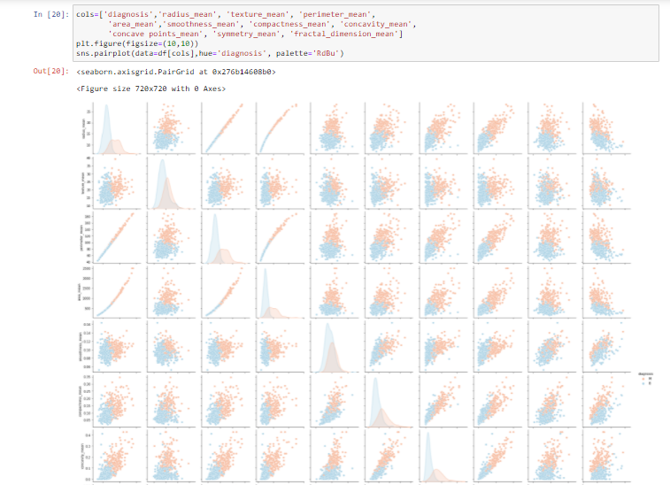

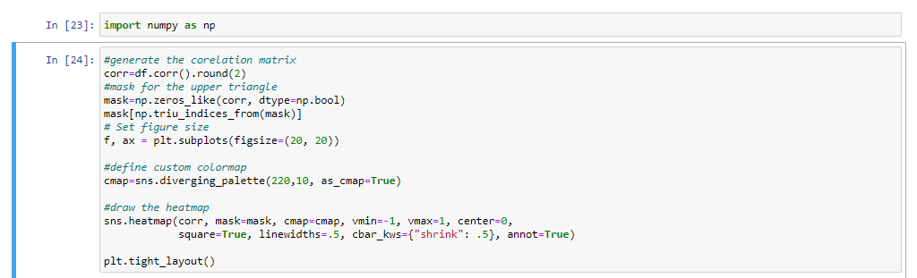

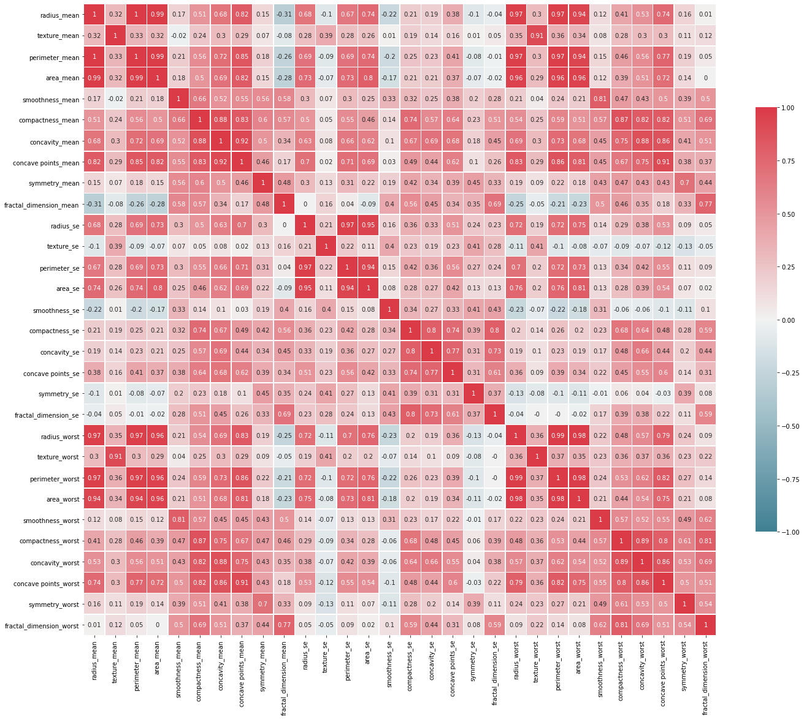

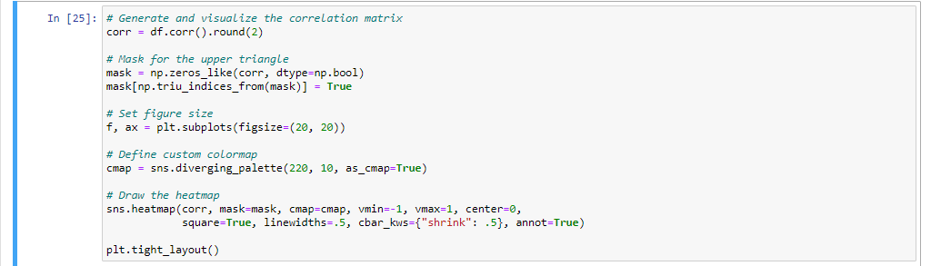

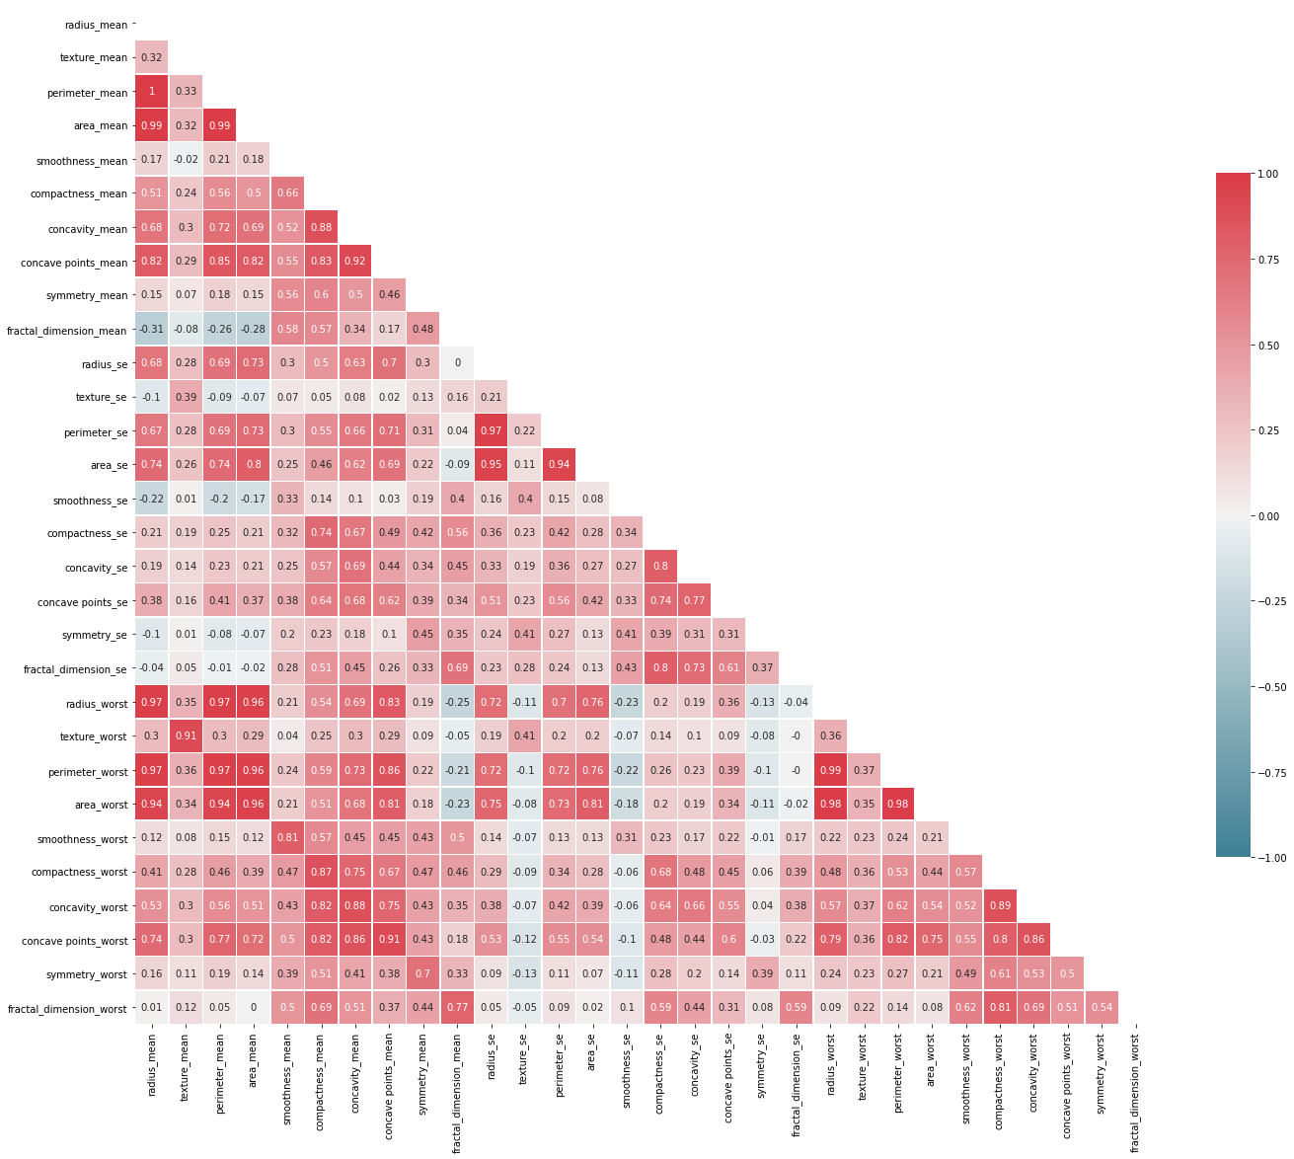

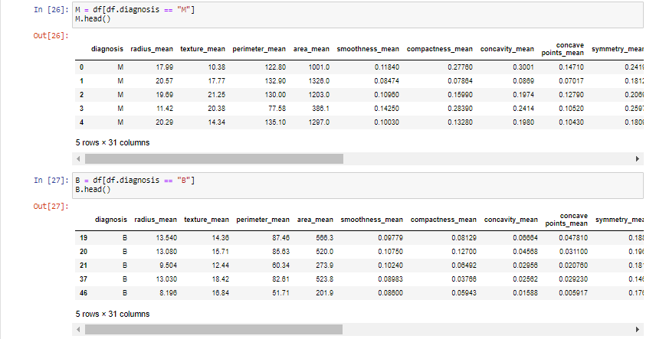

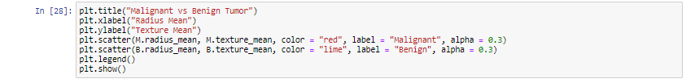

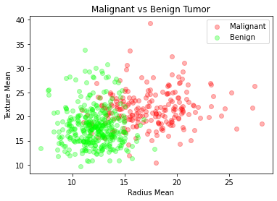

## ML ALGORITHM IMPLEMENTATION:

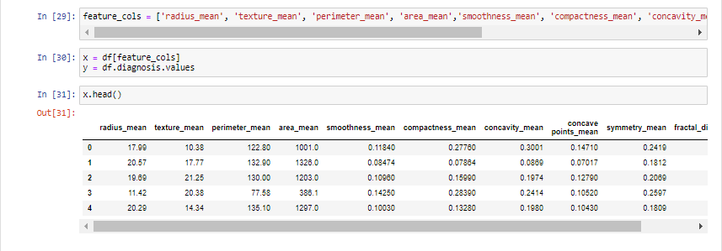

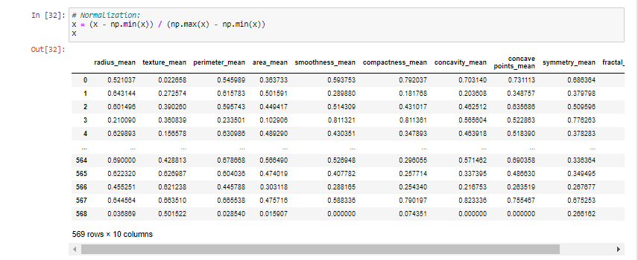

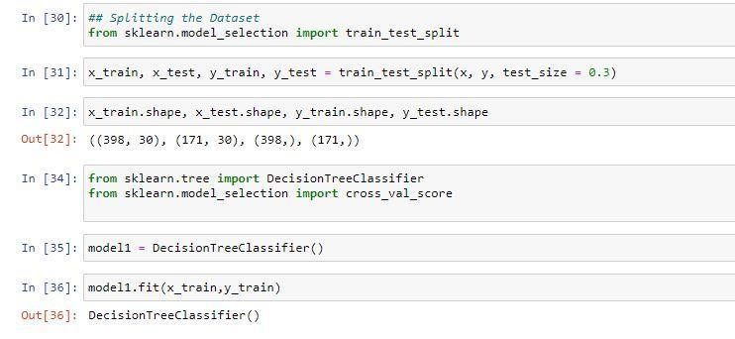

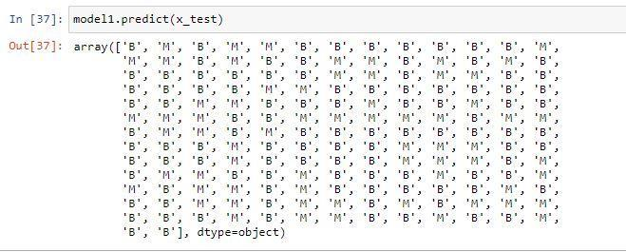

## FINAL RESULT:

